Collagen β(1-O) galactosyltransferase 1 regulates CD4+ T cells and alleviates Con A-induced liver injury partly via JAK-STAT signaling pathway

Meixin Gao 1, Herui Wei 1, Lingling He1, Shiwei Wang 1, Fan Xiao 2, Junru Yang 1, Yang Shu 1, Ping Li 1, Hongshan Wei 1#

1 Department of Gastroenterology, Beijing Ditan Hospital, Capital Medical University, No. 8 Jingshun East Street, Chaoyang District, Beijing 100015, China.

2 Institute of Infectious Diseases, Beijing Ditan Hospital, Capital Medical University, No. 8 Jingshun East Street, Chaoyang District, Beijing 100015, China.

# To whom correspondence should be addressed by Prof. Hongshan Wei: drwei@ccmu.edu.cn

Address: Department of Gastroenterology, Beijing Ditan Hospital, Capital Medical University,

No.8, Jingshun East Street, Chaoyang District, Beijing, 100015, China.

Meixin Gao, E-mail: [meixin1107@163.com](mailto:meixin1107@163.com)

Herui Wei, E-mail: [weiherui123@163.com](mailto:weiherui123@163.com)

Lingling He, E-mail: [lindahell@163.com](mailto:lindahell@163.com)

Shiwei Wang, E-mail: [yxbswsw@163.com](mailto:yxbswsw@163.com)

Fan Xiao, E-mail: [xiaofan@ccmu.edu.cn](mailto:xiaofan@ccmu.edu.cn)

Junru Yang, E-mail: [ruby_jryang@163.com](mailto:ruby_jryang@163.com)

Yang Shu, E-mail: [shuyang_bb@163.com](mailto:shuyang_bb@163.com)

Ping Li, E-mail: [endolp@126.com](mailto:endolp@126.com)

Hongshan Wei, E-mail: [drwei@ccmu.edu.cn](mailto:drwei@ccmu.edu.cn)

**Genotype identification of *OX-40(Cre)-GLT25D1* mice.** Firstly, we confirmed that GLT25D1 was expressed in CD4+ T cells (Fig. S3A). Then, we performed genotyping on conditional knockout mice. As shown in Fig.S3B, mice numbered 264, 265, 270, 271, 273, 274, 277, 278, 280, 282, 283, and 286 were *GLT25D1(fl/fl)* animals. Mice numbered 262, 267, 269, 271, 273, 275, and 278-282 were *OX40-Cre*-positive animals. Thus, the mice numbered 271, 273, 278, 280, and 282 were *OX-40(Cre)-GLT25D1(fl/fl)* mice. We compared the GLT25D1 expression in CD4+T cells in spleen between WT and *OX-40(Cre)-GLT25D1(fl/fl)* mice by flow cytometry (Fig. S3C). The results showed that the GLT25D1 was significantly decreased in CD4+ T cells of *OX-40(Cre)-GLT25D1(fl/fl)* mice compared with that of WT mice (Fig. S3C, D). Since OX-40 is an activation-induced gene, to further verify the conditional knockout, we compared the GLT25D1 expression in CD4+ T cells before and after Con A administration (Fig. S3C). It was found that GLT25D1 was reduced when CD4+ T cell activated by Con A-stimulation. In addition, to exclude the effects of naïve CD4 T cells on GLT25D1 expression, we detected the GLT25D1 in naïve CD4 T cells (Fig. S3E, F). The results showed that GLT25D1 hardly expressed in naïve CD4 T cells of *OX-40(Cre)-GLT25D1(fl/fl)* mice ((Fig. S3F).

Fig.S1.



Fig.S1. A, Identification of mouse genotypes by DNA gel electrophoresis. B, C, The expression of GLT25D1 protein in the liver of *GLT25D1(fl/fl)* and *GLT25D1+/-* mice before and after Con A induction for 12 h (n=3). *, and ** mean *P* < 0.05, and *P*<0.01, respectively. The experiments were repeated three times independently.

Fig.S2.

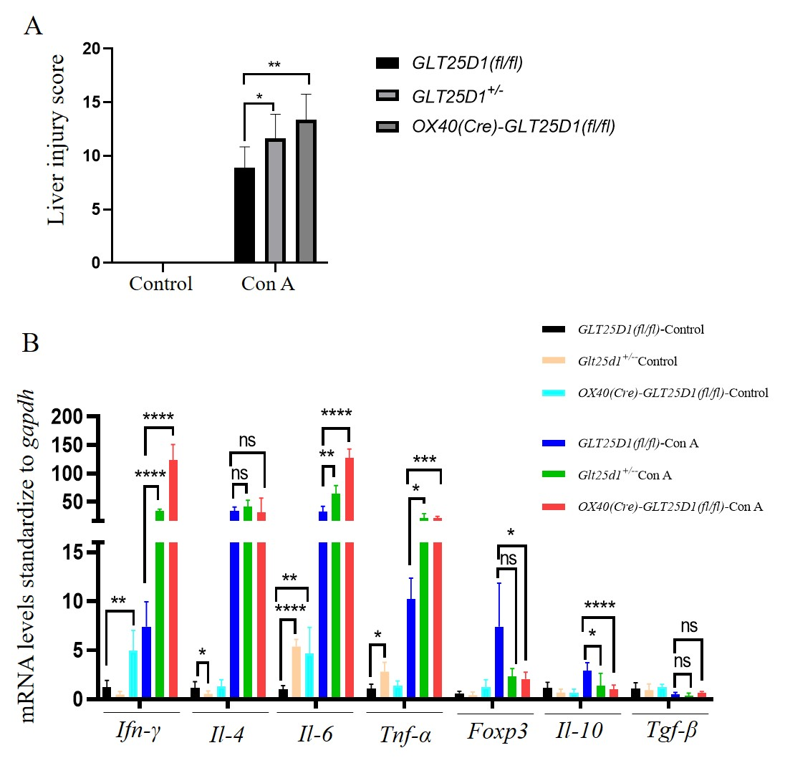

Fig.S2. A, assessment of liver pathological injury following Ishak’s guidelines in *GLT25D1(fl/fl)*, *GLT25D1+/-* and *OX40(Cre)-GLT25D1(fl/fl)* mice before and after Con A induction for 12 h (n=8). B, the transcription levels of cytokines or transcription factors (*Ifn-γ, Il-4, Il-6, Tnf-α, Foxp3, Il-10, Tgf-β*) of liver tissues from *GLT25D1(fl/fl)*, *GLT25D1+/-* and *OX40(Cre)-GLT25D1(fl/fl)* mice before and after Con A induction for 12 h (n=4-8). *，**, *** and **** mean *P* < 0.05, *P* < 0.01, *P* < 0.001 and *P* < 0.0001, respectively. “ns” means no statistical difference. The experiments were repeated three times independently.

Fig.S3.



Fig.S3. A, Expression of GLT25D1 in liver and CD4+ T cells of WT mice. B, Identification of mouse genotypes by DNA gel electrophoresis. P: Positive Control, B6: Negative Control, N: No-Template Control. C, the GLT25D1 expression in CD4+ T cells of spleen from WT and *OX-40(Cre)-GLT25D1(fl/fl)* mice. D, the MFI of GLT25D1 gated in CD4+ T cells of spleen from WT and *OX40(Cre)-GLT25D1(fl/fl)* mice (n=5). E, analytical strategy of naïve CD4+ T cells in spleen. F, the GLT25D1 expression in naïve CD4+ T cells of spleen from *OX-40(Cre)-GLT25D1(fl/fl)* mice. *，**, and *** mean *P* < 0.05, *P* < 0.01, and *P*<0.001, respectively. “ns” means no statistical difference. The experiments were repeated three times independently.

Fig.S4.



Fig.S4. A, the percentages of CD8+ T cells in the livers of *GLT25D1(fl/fl)* and *GLT25D1+/-* mice before and after Con A treatment for 12 h. B, the expression levels of CD69 in CD8+ T cells from the livers of *GLT25D1(fl/fl)* and *GLT25D1+/-* mice before and after Con A treatment for 12 h. *, and *** mean *P* < 0.05, and *P*<0.001, respectively. “ns” means no statistical difference. The experiments were repeated three times independently.